A361-A365-Asia-Japan-Hokkaido-Paleo-Ainu-35,000 BP

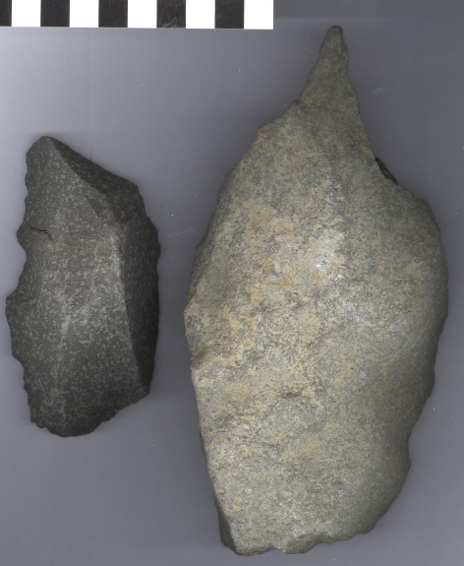 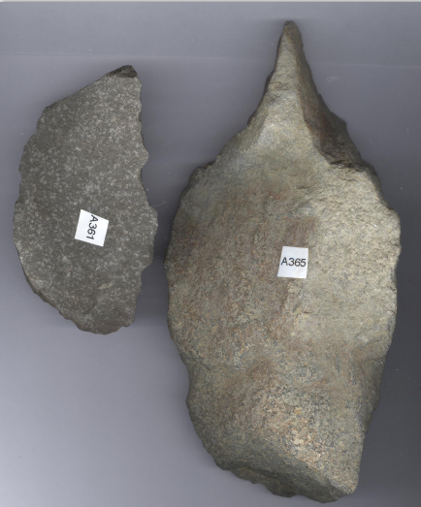

Asia-Japan-Hokkaido-Paleo-Ainu-Scraper and Handaxe, 35,000 BP

**Case No.: 1**

**Formal Label:** Japan-Hokkaido-Paleo-Ainu-Scraper and Handaxe, 35,000 BP

**Display Description: Rare Ainu Paleo Scraper and Hand Axe**

**Accession Number:** A361-A365

**LC Classification:** GN855.J2

**Date or Time Horizon:** Paleolithic, 35,000 BP

**Geographical Area: central Hokkaido**

**Map, GPS Coordinates:**

**Cultural Affiliation:** Ainu Paleolithic

**Medium:** basalt

**Dimensions:   
Weight:**

**Provenance:** Hokkaido

**Condition: original**

**Discussion:**

**References:**